Chapter 5, Problem 87

Figure 5.105 displays a two-op-amp instrumentation amplifier. Derive an expression for v_{o} in terms of v₁ and v₂. How can this amplifier be used as a subtractor?

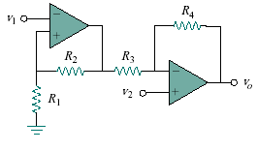
Figure 5.105
For Prob. 5.87.

